YEAR 10 SCIENCE
ENERGY AND CHANGE
REVISION (LIGHT)

1. How would you describe light - what is it?

2. What is the difference between a luminous and non-luminous object? Give an example of each.

3. Are your examples in Question 2 artificial or natural sources?

4. What is the difference between the terms transparent, translucent and opaque?

5. Explain why you can see a non-luminous object such as a chair.

6. Draw a ray diagram to show how the shadows are formed in the following situations. Label the shadows formed.

(a)
fluorescent tube
screen

(b) Draw in the Moon and rays to show a lunar eclipse.

Sun
Earth

7. Draw simple diagrams to show the difference between regular and diffuse (irregular) reflection.

8. Define the Laws of Reflection. Use a simple diagram to help your explanation.

9. What is the difference between a real image and a virtual image?

10. (a) Draw a ray diagram to show how the image of the object is formed.

(b) Describe the size, nature and position of the image produced.
11. (a) Draw the shape of a convex and concave mirror.
(b) What other names can be used for these mirrors?
(c) What is meant by the term focus for a concave mirror.
(d) Give one use for each of these mirrors.

12. Describe the images formed as a concave mirror is moved from arms length to your eye.

13. Complete the following ray diagrams.
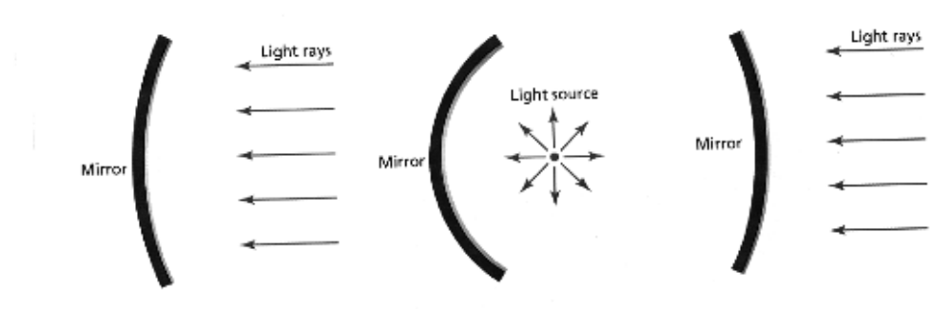

14. (a) Define the term refraction.
(b) Will a light ray refract when it enters a new medium at right angles (along the normal)?
(c) If a light ray enters a new medium where it speeds up, does it refract towards or away from
the normal?

15. (a) What is total internal reflection?
(b) Draw a simple diagram to show how it occurs.
(c) What is the critical angle?
(d) Give one example where total internal reflection is used.

16. Complete the following ray diagrams to show the path taken through the glass prisms.

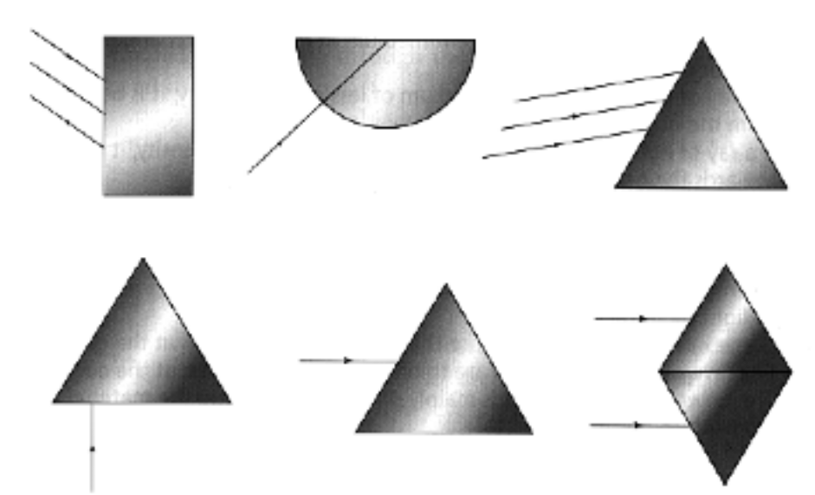

17. (a) If a person on a jetty wishes to spear a fish swimming in the water (not directly below), where should they aim?
(b) Draw a simple diagram to show this situation.

18. (a) If an object is placed a long way from a convex lens, what type of image is formed?
(b) Where should an object be placed when a convex lens is used as a magnifying glass?

19. Complete the following ray diagrams to show the most likely paths for the rays.
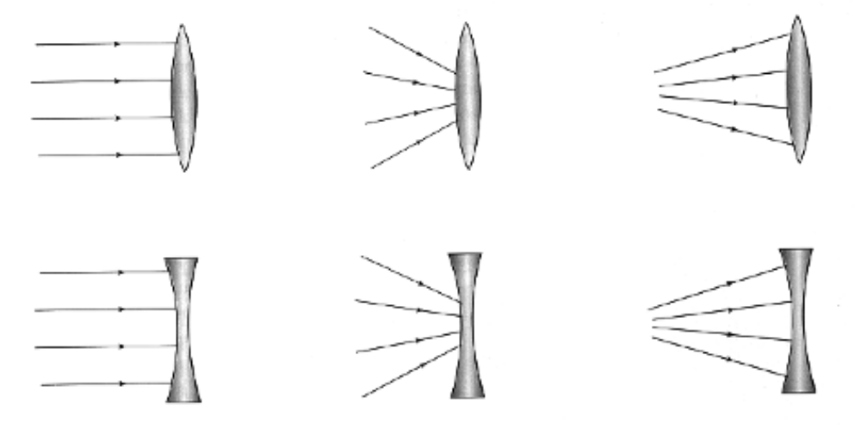220. (a) Draw a simple diagram of the eye and label the major parts.
(b) Give the major function for each part.

21. Describe how the lens of the eye changes to focus on a close object and a distant object.

22. (a) With the aid of simple diagrams, explain how a person is affected by short sight (myopia) and long sight (hypermetropia).
(b) How is each problem overcome?

23. What is the blind spot in the eye?

